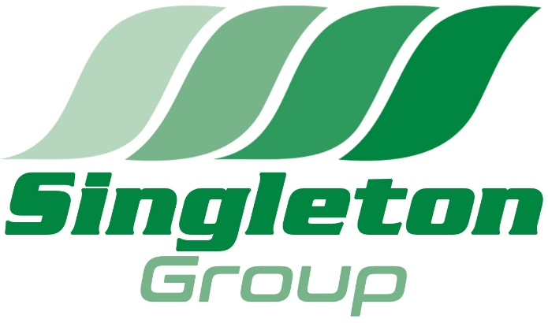
The Training Hub,
Unit 14 Deacon Rd Business Park,
Lincoln.
LN2 4JB
Tel: 01522 300161
Fax: 01522 543743
E-Mail: office@singleton-associates.org
Website: www.singleton-associates.org
VAT Reg. No. GB 829 2356 13

__________________________________________________________________

Applicant name:

Employer Company name: Singleton Event Services Ltd

By signing this document, you are giving consent to the completion of a DBS check by electronic submission.

All information requested is used solely for the purpose of producing a DBS check. The information will be stored and processed by UKCRBS ltd and Singleton Training Services Ltd in accordance with the General Data Protection Regulations (GDPR) 2018.

We will treat all personal information as confidential and we will not disclose it to any third party except:
- With prior agreement
- As necessary for providing the DBS check
- As required by law

By signing below you are agreeing to the following:

That on this date

- Give consent for the application to be processed
- Will represent your identity to be true
- Will corroborate your identity to be true via documentation
- Confirm that the information provided on the application is true and accurate to the best of your knowledge and belief

A record of your consent will be retained on your personnel file

Please confirm your consent by signing below.

Signed:

Print name: Date:

